**How to take Minutes…**

Taking minutes allows you to keep a formal record of your Committee meetings, helps you track the decisions that you made and provides a useful tool to your successors. This is normally the responsibility of the Society Secretary but throughout the year any Committee member may be called to take minutes in their absence. Detailed and well written minutes can really make the difference so please take some time to read this section.

Types of minutes

There are 2 styles of minute taking that you may use:

1) NARRATIVE MINUTES – where the minutes are an overview of the meeting and include any actions / outcomes of the meeting. These are most commonly used at the Students Union

2) ACTION MINUTES – these are just bullet points of actions, down the right hand column is written who is to carry out these actions

The MATTERS ARISING – are actions from previous meetings and are noted with the person responsible for each action given.

**Things to think about**

**Before the meeting:**

* Ensure the meeting room has been booked
* Make sure all those attending the meeting know where the meeting is being held and when
* Have the minutes of the previous meeting typed up and distributed at least 1 week (if possible) in advance, so that they can be read before the meeting
* If there is any extra documentation to be discussed on the agenda make sure this has been distributed before the meeting also
* Try and meet with the Chair (normally the Society President) before the meeting so you are sure of the agenda/ order of the meeting. If you do not meet with the chair, try to ensure you have the agenda before the meeting so you know what will be discussed

**During the meeting:**

* Note Date, Time and Title of the meeting
* Note everyone who is present and those (if any) who send apologies. If in doubt of names, send a blank piece of paper round and ask everyone to write their name (as a register)
* Ensure you have everyone’s name before the meeting starts and if you are not ready ask the Chair to please wait
* Also make a note of anyone absent from the meeting – i.e. anyone who should be there but has not sent apologies
* You need to have / know everyone’s names so you know who says what for the minutes
* Try to sit next to the Chair so if you have any queries it is easy to communicate with them
* State whether minutes from the previous meeting have been approved. Early on in the agenda a motion should be put forward to approve the minutes of the previous meeting. Approval is for verification of the accuracy of the minutes
* Don’t forget to note who proposes and seconds the approval of the minutes
* Make sure you have copies of papers being discussed at the meeting so you can refer to them at all times
* The minutes should follow the meeting – not necessarily the agenda.
* If members of the meeting arrive late / leave early, it must be noted at what point in the meeting this occurred for the purpose of the minutes
* Minutes should be an overview of what was discussed and any action points that arise from the discussions

**After the meeting**

* Write up your minutes as soon as possible so the meeting is still fresh in your mind and then send out to all meeting members.
* Make sure all names and titles are correct and spelt correctly
* In the minutes, for each agenda item, write an over view of what was discussed, making sure you note all important points and who they were addressed to / by. Finish section by concluding if any action points were agreed and who is responsible for ensuring the action is carried out.
* Email the minutes across to the Chair of the meeting for approval prior to circulating them to all members of the meeting
* Upload the minutes to your mini-site and send a copy to vpdevelopment@udsu.co.uk
* Book the time and room for the next meeting and circulate to all members

**Hints, Tips and Best Practice:**

* If you don’t understand something be confident enough to ask the Chair to clarify the point before the meeting continues
* Be prepared – have spare pens, copies of previous meetings and the agenda to hand and make sure everyone has copies
* Write notes legibly – for when you come to type up the minutes
* Be organised
* Make sure you know names of all meeting members
* Try to meet with the Chair before the meeting to ensure you know what the agenda is / what will be discussed
* Most importantly, ask yourself – if I were not at the meeting what would I need to know???

Examples of minute formats.

**Narrative Minutes:**

**Minutes of History Society Committee Meeting**

**Sunday December 25th 2011**

**2.00 pm - Room N101**

1. PRESENT: [list the Society Committee members names and roles]
   1. IN ATTENDANCE: (Observers – other Society members etc)
2. APOLOGIES: [list Society Committee members names and roles]
3. MINUTES OF THE LAST MEETING: - Wednesday November 23rd 2011

**The minutes from the last meeting held on the above date were approved and agreed as a true and accurate record by:**

Proposed by: Seconded by:

For: 4 Against: 0 Abstentions: 1 (no vote)

**The minutes are formally agreed and approved**.

1. MATTERS ARISING (Review of Actions from last meeting)

Any matters arising from the previous meeting will be discussed here. If it is not already on the agenda.

1. AGENDA ITEMS WILL GO HERE

Type discussion that occurred during the meeting.

1. A.O.B

Any Other Business – usually not itemised but items can and will occur.

1. NEXT MEETING

The next meeting of the History Society Committee will be held on Friday 20 the January 2012 at 1.00 pm.

Room TBC

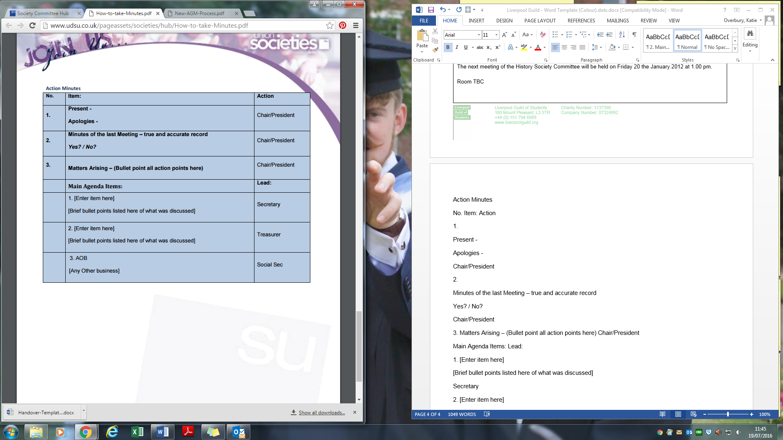**Action Minutes:**