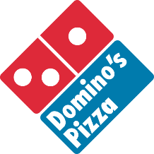 | Societies Pizza Deal:
 | Large pizza with 1 topping for £10

To order Dominos for your society, please fill in the following table and email to saadmin@liverpool.ac.uk with the subject: “Pizza – (Your society name)”
Society name:

Date for pizza DELIVERY:

Time for pizza dELIVERY:

Name of student collecting delivery:

Phone number of student collecting DELIVERY:

Your order:
eg. 1x margherita
1x pepperoni
2x peppers

Pizza is to be collected from the Guild Reception and payment will have been made directly from your society account to Dominos. You should never have to pay upon delivery. We will email to confirm your order has been placed and the amount that will be charged to your society account.

**Please place your orders at least 48 hours in advance of your event. Any orders submitted on a weekend will be reviewed on Monday mornings**
It is your responsibility to ensure all details on this order form are correct. Any errors will be charged to the society’s account.
Please note there is a £2.99 delivery charge on all orders and a minimum order size of 4 pizzas

This form should be completed by the individual who is giving their name & mobile number only. This form will be forwarded on to Dominos and they will use the contact details on this form only to contact the student on arrival.

Are you happy to for Liverpool Guild of Students to share your name and mobile number with Dominos London Road, Liverpool, when placing a pizza order for the society?
Yes No

You can find out more about how Liverpool Guild of Students manages and processes your data here.

